## Anna University - Wikipedia Naan Mudhalvan – KCG College of Technology

## 

**GOVERNMENT COLLEGE OF ENGINEERING [IRTT]**

 **ERODE: 638 316**

**Electronics and Communication Engineering**

**NAAN MUDHALVAN**

***SB8056-DIGITAL MARKETING***

***TEAM ID:*** ***NM2023TMID04450***

**PROJECT DOMAIN: DIGITAL MARKETING**

**PROJECT TITLE: BUILDING A WEBSITE USING CANVA**

*BRAND NAME: OFF-WHITE COLOURS*

*CATEGORY: APPAREL CLOTHING*

**TEAM MEMBERS**

|  |  |
| --- | --- |
| **REGISTER NUMBER** | **NAME** |
| **731120106026** | **SANMITHA S** |
| **731120106010** | **JANANI SUSMITHA N** |
| **731120106032** | **SUBHA SHREE K S** |
| **731120106021** | **NIRMALA DEVI G** |

**GOVERNMENT COLLEGE OF ENGINEERING (Formerly IRTT)**

**ERODE-638 316**



**BONAFIDE CERTIFICATE**

Certified that this project titled “**BUILDING A WEBSITE USING CANVA”**is the bonafide work of SANMITHA S (731120106026), JANANI SUSMITHA N (731120106010), SUBHA SHREE K S (731120106032) , NIRMALA DEVI G (731120106021) who carried out the project work under my supervision.

**SIGNATURE OF FACULTY EVALUATOR** **SIGNATURE OF FACULTY MENTOR**

**Dr.S.BHARATHI, M.Tech.,Ph.D** **Dr.S.BHARATHI, M.Tech.,Ph.D**

ASSISTANT PROFESSOR, ASSISTANT PROFESSOR(SR),

DEPARTMENT OF ECE, DEPARTMENT OF ECE,

GOVERNMENT COLLEGE OF ENGINEERING, GOVERNMENT COLLEGE OF ENGINEERING,

ERODE- 638316 ERODE- 638316

**SIGNATURE OF SPOC**  **SIGNATURE OF HOD**

Dr.K.MURUGAN ,M.E,Ph.D, Dr.R.VALARMATHI ,M.E,Ph.D,

ASSISTANT PROFESSOR, PROFESSOR/HEAD OF THE DEPARTMENT,

DEPARTMENT OF IT, DEPARTMENT OF ECE,

GOVERNMENT COLLEGE OF ENGINEERING, GOVERNMENT COLLEGE OF ENGINEERING,

ERODE- 638316. ERODE-638316

**ABSTRACT**

BUILDING A WEBSITE USING CANVA

Our project outlines the process of building a visually appealing and user-friendly website for a clothing brand using Canva, a popular graphic design tool. Canva is known for its versatility and user-friendliness, making it an excellent choice for both beginners and experienced designers. The website development process begins with a comprehensive analysis of the brand's identity, target audience, and business objectives. Canva provides a wide array of templates, design elements, and customization options, making it easy to create a unique and on-brand website. The process of building a visually appealing and user-friendly website for a clothing brand using Canva, a popular graphic design tool.

**TABLE OF CONTENTS**

1. **INTRODUCTION**

1.1 Introduction to canva

1.2 Project Overview

1.3 Purpose

2. **BRAINSTORMING AND IDEATION PHASE**

2.1 Problem Statement and Understanding

2.2 Empathy Map Canvas

2.3 Brainstorming and Ideation Phase

2.4 Proposed Solution

3.  **PROJECT ANALYSIS**

3.1 Functional requirement

3.2 Non-Functional requirements

**4. PROJECT DESIGN**

4.1 User-Centric Navigation Design

4.2 Branding Integration and Customization

4.3 Integration plugins and Widgets

4.4 Responsive Design and Cross-Platform Compatibility

**5. DIGITAL MARKETING STATEGY**

5.1 Optimizing for Mobile and SEO

5.2 Rationale for chosen digital channels and platforms

5.3 Key messaging decisions

5.4 Branding decision

**6.IMPLEMENTATION PLAN**

6.1 Brand Logo

6.2 Content marketing

6.3 Social media strategy

6.4 Publishing the website

**7. RESULT AND ANALYSIS**

**8. PROJECT SCOPE AND OBJECTIVES**

**9. CONCLUSION**

**10. APPENDIX**

**GitHub & Project Video Demo Link**

**CHAPTER 1**

**INTRODUCTION**

**1.1 INTRODUCTION TO CANVA**

Canva is a user-friendly graphic design platform that offers a variety of tools and templates for creating visually appealing content, including websites. With its intuitive interface and extensive library of design elements, Canva simplifies the process of website creation, making it accessible even for users with minimal design experience.

Canva easy-to-use drag-and-drop interface, diverse design templates, and extensive library of images and graphics make it an ideal choice for building visually engaging websites without the need for complex coding. Its responsive design options and user-friendly features cater to both beginners and experienced designers, enabling the creation of professional-looking websites in a short period.

**1.2 PROJECT OVERVIEW**

Building a website using Canva is a user-friendly and creative process that leverages Canva's design tools and templates to create a visually appealing and functional website. Canva, primarily known for its graphic design capabilities, now offers a feature called Canva Websites, which simplifies website creation for users without extensive coding or design skills.

Users can choose from a variety of professionally designed templates, customize them with their own content, images, and branding elements, and publish their website with ease. Canva Websites provides a convenient drag-and-drop interface, making it accessible to beginners and small businesses looking to establish an online presence quickly and affordably.

The introduction of Canva Websites has revolutionized the web development landscape, particularly for small businesses and entrepreneurs seeking a hassle-free and cost-effective way to establish their online presence.

**1.3 PURPOSE**

The purpose of initiating the project "building a website using Canva" is to harness the platform's intuitive design tools and user-friendly features to create a visually captivating and functional website. By leveraging Canva's simplified interface and diverse template options, the project aims to streamline the website development process, catering to individuals and businesses seeking a cost-effective and efficient solution for establishing their online presence.

This endeavour is driven by the goal of empowering users with limited technical expertise to independently craft a compelling web presence that aligns with their brand identity and effectively communicates their message to a wider audience. Additionally, the project seeks to facilitate a creative and accessible approach to website construction, encouraging innovation, and enabling users to develop essential design skills in a supportive and educational environment.

Ultimately, the project's overarching objective is to enable users to create a professional and visually appealing website without the complexities and costs typically associated with traditional web development, thus fostering autonomy, creativity, and a strong online identity.

**CHAPTER 2**

**BRAINSTORMING AND IDEATION PHASE**

**2.1 PROBLEM STATEMENT AND UNDERSTANDING**

**Problem statement:**

The project "building a website using Canva" aims to address the challenges faced by individuals and businesses lacking technical expertise and substantial financial resources in establishing a visually appealing and functional online presence. These challenges typically include the complexities of traditional web development processes, high costs associated with hiring professional designers or developers, and the time-consuming nature of creating a customized website from scratch. The absence of user-friendly tools for creating professional websites often hinders the ability of small businesses, entrepreneurs, and individuals to effectively communicate their brand message and engage with their target audience.

**Understanding:**

The project recognizes the need for a simplified and accessible solution to enable users with limited technical skills to construct an engaging website that reflects their unique brand identity. It acknowledges the significance of user-friendly interfaces and cost-effective alternatives to conventional web development tools, aiming to empower users to independently build and manage their online presence without the need for extensive coding knowledge or substantial financial investments.

By leveraging Canva's intuitive design tools and pre-designed templates, the project seeks to facilitate a creative and efficient approach to website development, fostering a supportive environment for users to explore their design capabilities and effectively convey their message to a broader audience. The understanding of the project underscores the importance of democratizing website creation, encouraging creativity, and providing a platform that encourages users to establish a compelling and professional online identity while minimizing the technical and financial barriers associated with traditional web development processes.

**2.2 EMPATHY MAPPING CANVAS**

An empathy map is a simple, easy-to-digest visual that captures knowledge about a user’s behaviours and attitudes.

It is a useful tool to helps teams better understand their users.

Creating an effective solution requires understanding the true problem and the person who is experiencing it. The exercise of creating the map helps participants consider things from the user’s perspective along with his or her goals and challenges.

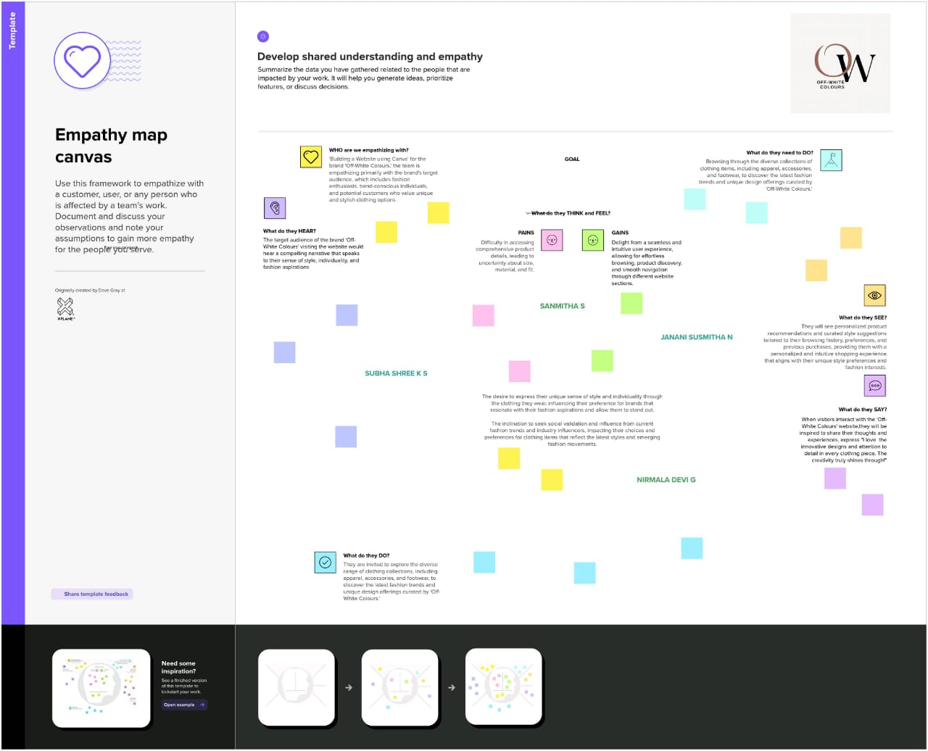

**2.3 BRAINSTORMING AND IDEATION PHASE**

Brainstorming provides a free and open environment that encourages everyone within a team to participate in the creative thinking process that leads to problem solving. Prioritizing volume over value, out-of-the-box ideas are welcome and built upon, and all participants are encouraged to collaborate, helping each other develop a rich amount of creative solutions.

Use this template in your own brainstorming sessions so your team can unleash their imagination and start shaping concepts even if you're not sitting in the same room.

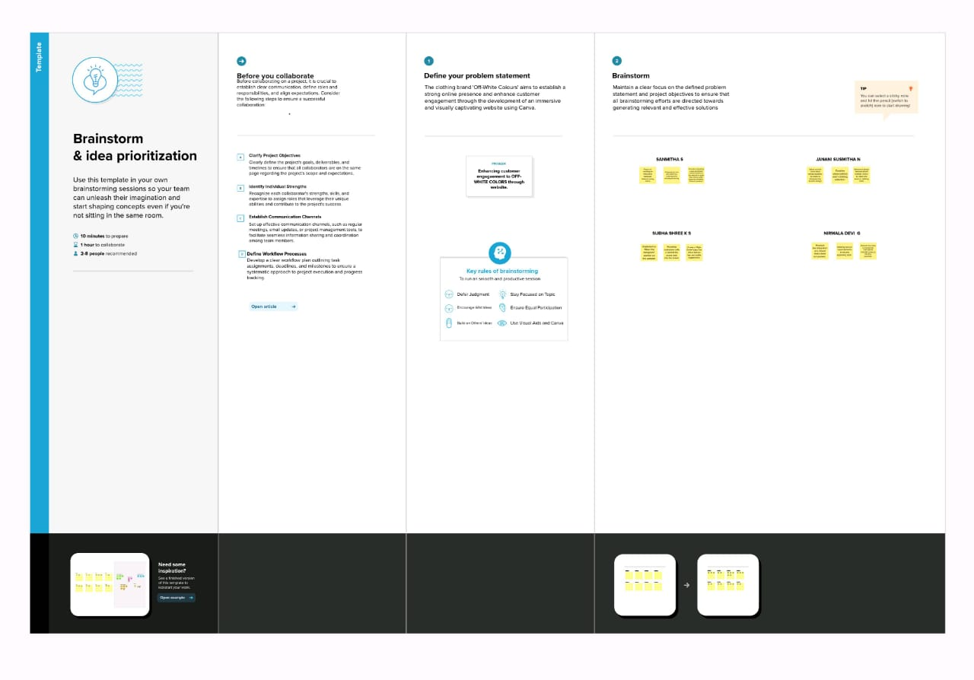

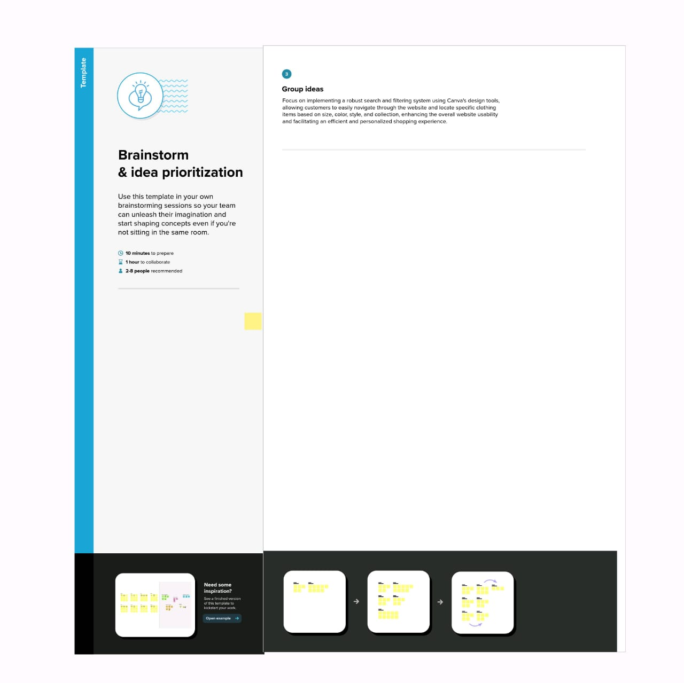

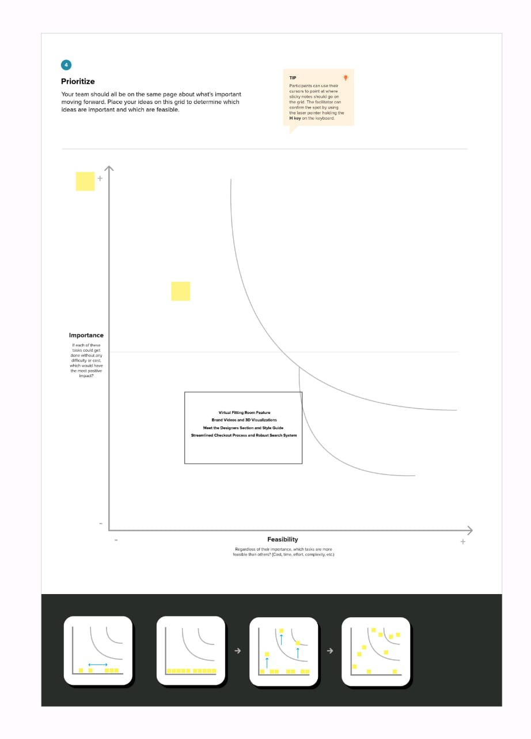

**2.4 PROPOSED SOLUTIONS**

* Identifying Target Audience: Brainstorm to define the specific target audience for the website, considering demographics, interests, and user preferences. This will help in customizing the website design to cater to the audience's needs and preferences.
* Exploring Branding Elements: Ideate on the branding elements, including colours, fonts, and visual styles, to ensure consistency with the overall brand identity. Consider how these elements can be integrated into the website design to create a cohesive and recognizable brand image.
* Content Planning: Brainstorm content ideas such as compelling text, engaging visuals, and multimedia elements that effectively convey the brand's message and offerings. Consider the use of storytelling techniques to enhance user engagement and create a memorable browsing experience.
* User Experience Design: Ideate on the website's user interface and experience, focusing on intuitive navigation, clear calls-to-action, and a responsive layout for various devices. Discuss interactive features and functionalities that can enhance user engagement and encourage user interaction.
* Customization Options: Brainstorm ideas for customizing Canva's templates to create a unique and visually appealing website design. Discuss ways to modify layouts, graphics, and other design elements to reflect the brand's personality and differentiate the website from competitors.
* Integration of Multimedia: Explore the possibilities of integrating multimedia elements such as videos, animations, and interactive graphics to enhance the website's visual appeal and convey information in an engaging and interactive manner.
* SEO and Analytics Considerations: Ideate on strategies to optimize the website for search engines and discuss the integration of analytics tools to track user behaviour and measure the website's performance. Consider ways to incorporate relevant keywords and meta tags to improve the website's visibility and ranking on search engines.
* Responsive Design Planning: Brainstorm ideas for ensuring the website's responsiveness across various devices and screen sizes. Discuss strategies to optimize the website's layout and content to provide a seamless user experience on desktops, tablets, and smartphones.
* Call-to-Action Strategy: Ideate on effective call-to-action strategies that encourage user engagement and drive conversions. Discuss the placement of call-to-action buttons, forms, and other interactive elements to guide users toward desired actions, such as making a purchase or signing up for a newsletter.
* Feedback Mechanism: Brainstorm ideas for incorporating a feedback mechanism, such as user surveys or feedback forms, to gather insights on user satisfaction and identify areas for improvement. Discuss the implementation of user feedback to refine the website design and enhance the overall user experience.
* By considering these brainstorming and ideation ideas, the project report can lay a solid foundation for the website's design and development process, ensuring a comprehensive and well-thought-out approach to building a successful website using Canva.

**CHAPTER 3**

**PROJECT ANALYSIS**

**3.1 FUNCTIONAL REQUIREMENTS**

**Template Selection:**

The user should be able to choose from a variety of pre-designed website templates available on Canva, catering to different industries and design preferences.

**Customization Tools:**

Canva should provide a user-friendly interface and a robust set of customization tools, allowing users to modify templates, including adjusting colors, fonts, layout structures, and other design elements according to their brand identity and preferences.

**Content Integration:**

The platform should support the integration of various content types, such as text, images, videos, and graphics, enabling users to seamlessly incorporate their own content into the website design.

**Drag-and-Drop Functionality:**

Canva's interface should allow users to easily drag and drop elements within the templates, facilitating the effortless arrangement and customization of the website's components without the need for complex coding.

**Responsive Design:**

The website created using Canva should be responsive, ensuring that it can adapt to different screen sizes and devices, providing a consistent and user-friendly experience for visitors accessing the site from desktops, tablets, and smartphones.

**Preview Feature:**

Canva should offer a preview feature that enables users to visualize how their website will appear to visitors before publishing, allowing them to make necessary adjustments and ensure the website's visual integrity and functionality.

**Integration of Interactive Elements:**

The platform should support the integration of interactive features such as forms, buttons, and links, enabling users to create engaging and user-friendly functionalities, including contact forms, social media links, and other interactive components.

**SEO Optimization Tools:**

Canva should provide basic SEO optimization tools, allowing users to add metadata, alt tags, and other relevant elements to improve the website's visibility and search engine ranking, facilitating better online discoverability.

**Preview and Testing Tools:**

The platform should offer tools for users to preview and test the website's functionality and design across different devices and browsers, ensuring a seamless and error-free user experience before publishing the website

**.**

**Publishing Options:**

Canva should provide easy publishing options, enabling users to seamlessly launch their websites with a click of a button and offering various hosting and domain connection options for a smooth deployment process.

**3.2 NON-FUNCTIONAL ANALYSIS**

**Usability:**

The website should have an intuitive and easy-to-navigate interface, ensuring that users can efficiently access information and engage with the content without encountering any confusion or usability issue

**Performance:**

The website should load quickly and respond promptly to user interactions, providing a seamless browsing experience across different devices and internet connections to minimize user frustration and encourage prolonged engagement.

**Scalability:**

The website's design and infrastructure should be scalable to accommodate potential increases in user traffic and content expansion, ensuring that the site remains stable and performs efficiently even during periods of high user activity.

**Security:**

The website should implement robust security measures to safeguard user data, prevent unauthorized access, and protect against potential cyber threats or data breaches, ensuring the privacy and confidentiality of user information.

**Compatibility:**

The website should be compatible with various web browsers, operating systems, and devices, ensuring consistent functionality and visual consistency regardless of the platform or technology used to access the site.

**Reliability:**

The website should be reliable and available for access at all times, minimizing downtime and service disruptions to maintain a positive user experience and uphold the credibility and trustworthiness of the brand.

**Accessibility:**

The website should comply with accessibility standards, ensuring that individuals with disabilities can access and navigate the site using assistive technologies, such as screen readers or keyboard navigation, to promote inclusivity and equal access for all users.

**Compliance:**

The website should adhere to relevant industry standards, regulations, and legal requirements, including data protection regulations, copyright laws, and any other compliance obligations, to mitigate legal risks and ensure ethical business practices.

**Backup and Recovery:**

The website should have a robust backup and recovery system in place to regularly back up data and content, enabling quick restoration in the event of data loss, system failures, or other unforeseen incidents, to prevent significant disruptions to the website's operation.

**CHAPTER 4**

**PROJECT DESIGN**

**4.1 User-Centric Navigation Design**

Incorporating user-centric design principles, such as intuitive information architecture, responsive layouts, and accessible design elements, ensures that the website caters to the diverse needs and preferences of the target audience. Prioritizing user experience through clear visual hierarchy, legible typography, and easily accessible contact information fosters a user-friendly interface, promoting longer user engagement and fostering positive interactions with the website's content and features.

**4.2 Branding Integration and Customization**

**4.2.1Establishing Brand Consistency Across the Website :**

Integrating consistent branding elements, such as the logo, color palette, and typography, across all web pages fosters a cohesive and recognizable brand identity. Ensuring that the website's visual elements reflect the brand's values and messaging helps in reinforcing brand recognition and building a strong emotional connection with the target audience, thereby fostering trust and loyalty.

**4.2.2 Customizing Design Elements to Reflect Brand Personality :**

Tailoring design elements, including background images, icons, and buttons, to align with the brand's unique personality and tone of voice contributes to creating a distinct and memorable online presence. Incorporating brand-specific visual motifs and thematic imagery that resonate with the brand's narrative and storytelling enhances the website's visual appeal and establishes a strong brand association in the minds of the website visitors.

**4.2.3 Integrating Brand Storytelling into Website Content :**

Integrating the brand's narrative and values into the website's content, including the About Us page, product descriptions, and blog posts, enables the audience to connect with the brand on a deeper and more personal level. Communicating the brand's origin, mission, and customer-centric approach through compelling storytelling enhances the brand's authenticity and fosters meaningful relationships with the target audience, ultimately driving brand loyalty and advocacy

**4.3 Integration plugins and Widgets**

**4.3.1 Adding Social Media Buttons :**

Incorporating social media buttons into the website design allows for seamless integration with various social platforms, encouraging user engagement and content sharing.

**4.3.2 Embedding Contact Forms and Surveys :**

Canva enables users to embed contact forms and surveys into their websites, facilitating direct communication with visitors and gathering valuable feedback.

**4.3.3 Enhancing Functionality with Social Media Integration**

Incorporating social media integration plugins allows users to seamlessly share website content across various social platforms, thereby increasing the website's visibility and fostering user engagement. Implementing social sharing buttons, social media feed displays, and social login options enables users to interact with the website's content more effectively and promotes a sense of community and connectivity among website visitors.

**4.4 Responsive Design and Cross-Platform Compatibility :**

**4.4.1 Customizing Layouts and Color Schemes :**

Utilizing Canva's customization options for layouts and color schemes allows for the creation of visually appealing and cohesive designs that align with the website's branding and purpose.

**4.4.2 Adding and Editing Text and Headings :**

Canva's text editing tools enable users to easily add, format, and edit text and headings to ensure clear and effective communication of the website's content.

**4.4.3 Incorporating Images, Videos, and Graphics :**

The extensive library of images, videos, and graphics available on Canva enables users to enhance their website's visual appeal by incorporating high-quality multimedia elements that complement the overall design.

**4.4.4 Using Canva Elements for Interactive Features :**

Canva offers a range of interactive elements, such as buttons, links, and animations, that can be incorporated into the website design to enhance user engagement and navigation

* + 1. **Seamless User Experience :**

Utilizing Canva's responsive design features allows for the creation of a website that seamlessly adapts to various screen sizes, including desktops, laptops, tablets, and smartphones. Implementing flexible layouts, fluid grids, and adjustable images ensures that the website maintains its visual integrity and functionality across different devices, providing users with an optimal viewing experience and fostering increased engagement and user satisfaction.

**4.4.6 Ensuring Cross-Platform Compatibility for Enhanced Accessibility :**

Conducting rigorous cross-platform compatibility tests across multiple web browsers, including Google Chrome, Mozilla Firefox, Safari, and Microsoft Edge, ensures that the website functions consistently and flawlessly across different platforms. Adhering to web standards and best practices for coding and design elements aids in achieving cross-platform compatibility, enabling users to access the website seamlessly irrespective of the device or browser they are using, ultimately fostering a broader reach and improved user engagement.

**CHAPTER 5**

**DIGITAL MARKETING STATERGY**

**5.1 Optimizing for Mobile and SEO :**

**5.1.1 Ensuring Responsive Design :**

Prioritizing a mobile-first approach during the design process ensures that the website's layout, content, and interactive elements are optimized for mobile devices, providing users with a seamless and intuitive browsing experience. Incorporating touch-friendly navigation, legible text, and appropriately sized images aids in delivering a user-centric design that prioritizes accessibility and ease of use, thereby fostering increased user engagement and satisfaction.

**5.1.2 Implementing Mobile-Friendly Elements :**

Optimizing image and multimedia file sizes, leveraging browser caching, and minimizing server response time significantly improve the website's load speed and overall performance on mobile devices. Implementing lazy loading for images and videos, as well as compressing CSS and JavaScript files, contributes to reducing page load times, ensuring that users can access and navigate the website swiftly and effortlessly, thereby enhancing user satisfaction and retention.

**5.1.3 Basic SEO Tips for Canva Websites :**

Incorporating relevant keywords naturally within the website's content, including meta tags, titles, and descriptions, assists in improving the website's visibility and search engine rankings. Conducting keyword research to identify high-impact keywords and implementing them strategically across the website's content aids in attracting organic traffic and increasing the website's online presence, ultimately leading to higher user engagement and conversion rates.

**5.2 Rationale for chosen digital channels and platforms**

* In selecting Canva as the digital platform for building a website, several key factors were considered. Canva, known primarily for its user-friendly graphic design tools, offers a seamless and intuitive interface that simplifies the website development process, particularly for users with limited technical expertise.
* With a wide array of customizable templates, Canva provides a diverse range of design options, enabling the creation of visually appealing and professional-looking websites tailored to specific business needs and branding requirements.
* Moreover, Canva's responsive design features ensure that websites created on the platform are optimized for a variety of devices, including desktops, tablets, and smartphones. This capability aligns with the current trend toward mobile-centric browsing, allowing businesses to reach a broader audience and enhance user engagement across multiple platforms.
* Additionally, Canva's extensive library of images, illustrations, and icons offers a rich resource for creating visually captivating and engaging website content. The platform's integration of user-friendly plugins and widgets simplifies the incorporation of interactive elements, such as contact forms, social media buttons, and e-commerce integrations, thereby enhancing the website's functionality and user experience.
* Furthermore, the ease of collaboration and sharing within the Canva platform enables seamless teamwork among designers, content creators, and stakeholders, facilitating efficient communication and workflow management throughout the website development process.
* By leveraging Canva's user-friendly interface, responsive design capabilities, rich content library, and collaborative features, the chosen digital platform presents a practical and effective solution for building a professional and visually engaging website.

**5.3 Key messaging decisions :**

**5.3.1 Brand Storytelling:**

Crafting a compelling brand narrative that highlights the unique heritage, craftsmanship, and design philosophy of 'Off-White Colours' engages customers on an emotional level. Using Canva's customizable multimedia features to showcase the brand's journey, inspirations, and creative process aids in creating an authentic and relatable brand story that resonates with the target audience.

**5.3.2 Product Value Proposition:**

Communicating the distinctive features, quality materials, and innovative designs of 'Off-White Colours' products through engaging product descriptions and visuals helps customers understand the brand's value proposition. Leveraging Canva's design tools to create visually appealing product showcases and highlighting key product benefits and functionalities aids in conveying the brand's commitment to delivering high-quality, unique, and stylish clothing options to its customers.

**5.3.3 Customer-Centric Approach:**

Emphasizing the brand's commitment to exceptional customer service, seamless shopping experiences, and personalized styling advice fosters a customer-centric brand image. Using Canva's interactive design elements to create personalized customer engagement tools, such as style quizzes, virtual lookbooks, and fashion trend guides, enhances the brand's relationship with its customers and reinforces its dedication to catering to their individual preferences and needs.

**5.4 Branding Decisions for 'Off-White Colours' Clothing Brand:**

**Visual Brand Identity:**

Developing a cohesive visual brand identity that reflects the brand's aesthetics, including colour schemes, typography, and imagery, establishes a strong and recognizable brand presence. Leveraging Canva's customizable design templates and visual elements to maintain consistency in brand visuals across the website reinforces the brand's identity and creates a memorable and impactful brand experience for customers.

**Emphasis on Creativity and Individuality:**

Showcasing the brand's creativity, innovation, and celebration of individual style through dynamic and artistic visual presentations sets 'Off-White Colours' apart. Utilizing Canva's creative design features to curate visually stunning and unique website layouts, graphics, and promotional materials that highlight the brand's commitment to fostering self-expression and originality resonates with customers who value individuality and artistic expression in their clothing choices.

**Social and Environmental Responsibility:**

Communicating the brand's commitment to sustainability, ethical practices, and social responsibility through visual storytelling and transparent messaging establishes 'Off-White Colours' as a socially conscious and environmentally aware brand. Utilizing Canva's multimedia capabilities to showcase the brand's eco-friendly initiatives, community partnerships, and responsible sourcing practices demonstrates the brand's dedication to making a positive impact on both the fashion industry and the world at large.

**CHAPTER 6**

**IMPLEMENTATION PLAN**

**6.1 Brand Logo**

The logo serves as the visual representation of the brand's identity and is a crucial element in establishing brand recognition and fostering a memorable brand image. For the project 'Building a Website using Canva,' the logo for the website can be introduced and defined as the primary visual mark that embodies the brand's unique values, mission, and aesthetic essence. Utilizing Canva's design tools, the logo can be created to reflect the brand's personality, incorporating relevant design elements, color schemes, and typography that align with the brand's overall visual identity.



This is the logo of our brand **“OFF-WHITE COLOURS**” under the category of online clothing apperal.

**6.2 Content Marketing**

To access Canva's user-friendly design platform, follow these simple steps:

**Step 1:** **Open a Web Browser**

Launch your preferred web browser, such as Google Chrome

**Step 2:** **Visit the Canva Website**

Type [www.canva.com](http://www.canva.com) in the address bar and press "Enter" to navigate to Canva's official website.

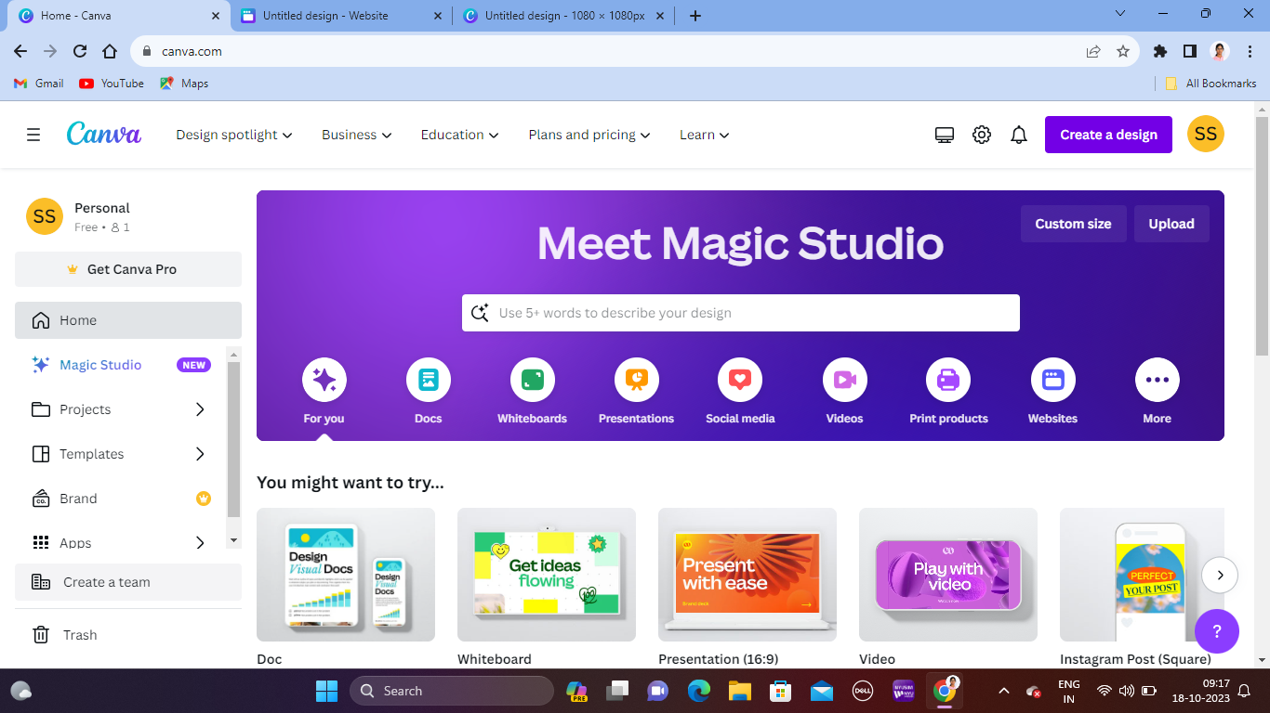

**Step 3:** **Sign In or Sign Up**

If you already have a Canva account, click on the "Log In" button and enter your credentials to access your account. If you are new to Canva, click on the "Sign Up" button and follow the prompts to create a new account.

**Step 4:** **Explore the Dashboard**

Once you are logged in, you will be directed to the Canva dashboard, which serves as the central hub for all your design projects.

**Step 5: Search for website**

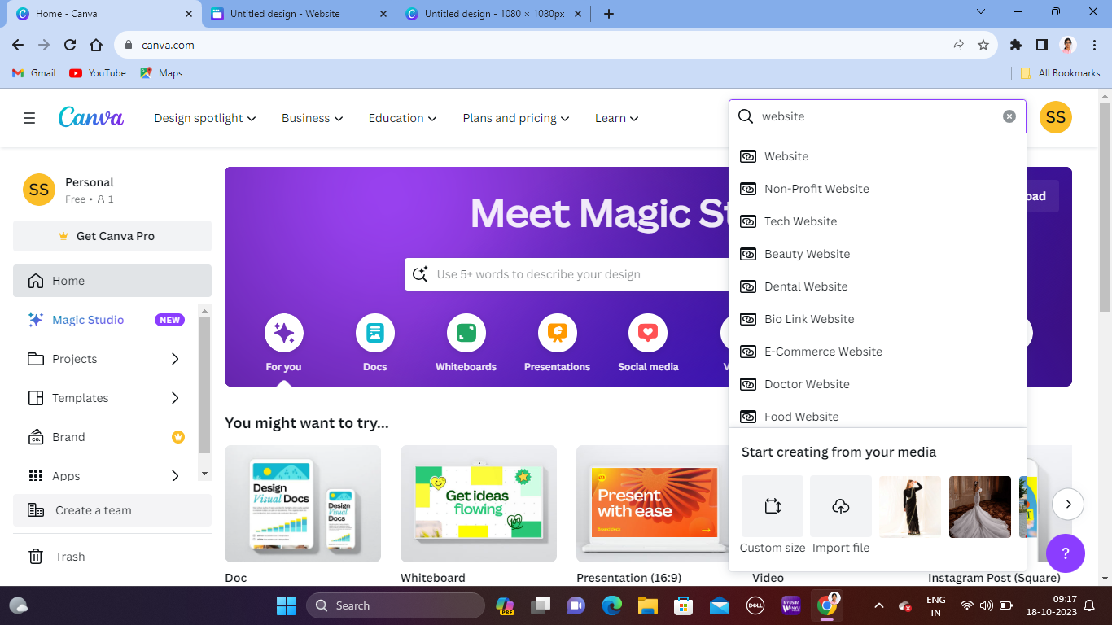

On the top right corner you can see a search bar, search for website templates.

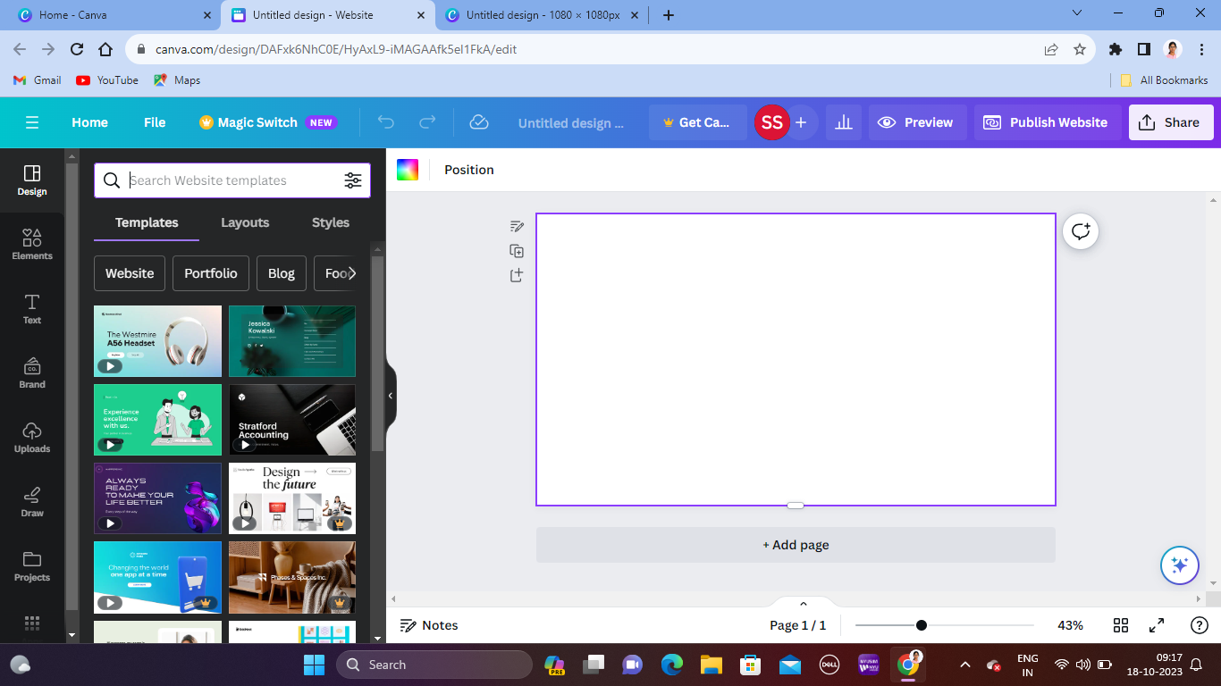

Then you will be navigated to a blank template page to edit the website.

**Step 6:** **Choosing a Clothing Brand Template**

Browse through the available clothing brand templates to find the most suitable one for your project. Select the desired template by clicking on it to begin the editing process.

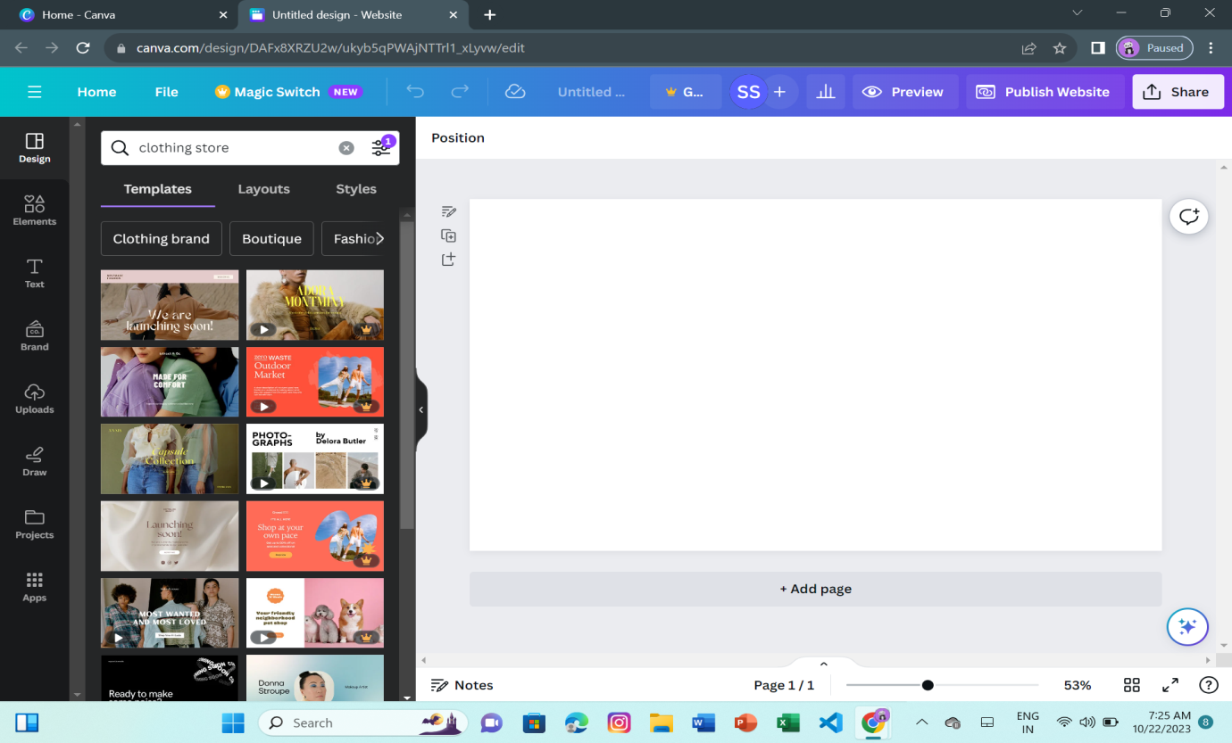

**Step 7:** **Customizing the Template**

Utilize Canva's user-friendly editing tools to customize the clothing brand template according to your brand's style and preferences. Edit the template's text, images, colors, and layout to align with your clothing brand's unique identity and aesthetic.

* Accessing Canva:

Immerse yourself in the digital wonderland of Canva, your gateway to infinite design possibilities.

* Creating a New Design:

Click, and watch as the "Create" button ignites a spark of creativity, signaling the start of your design journey.

* Selecting Website Design:

Type 'W-E-B-S-I-T-E' in the search bar, and witness as the letters dance into a magical portal leading you to a realm of website design options.

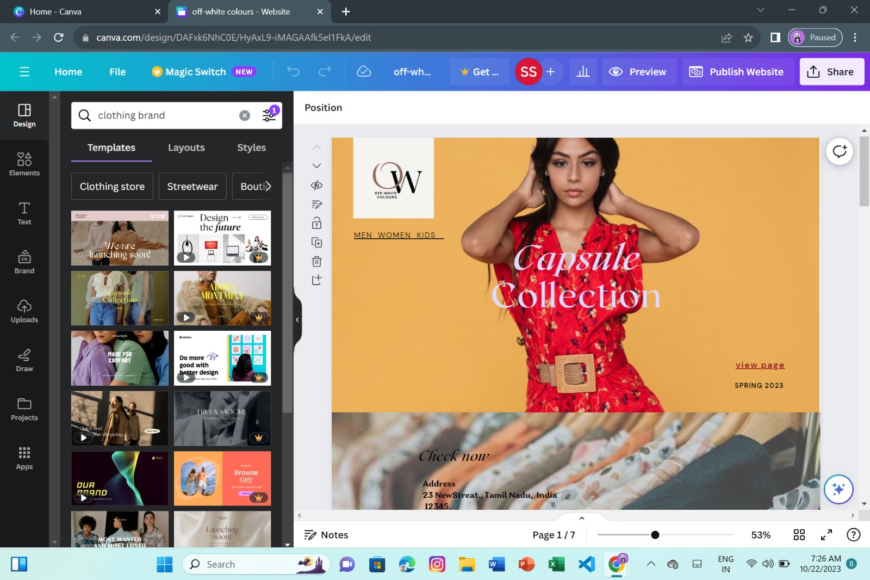

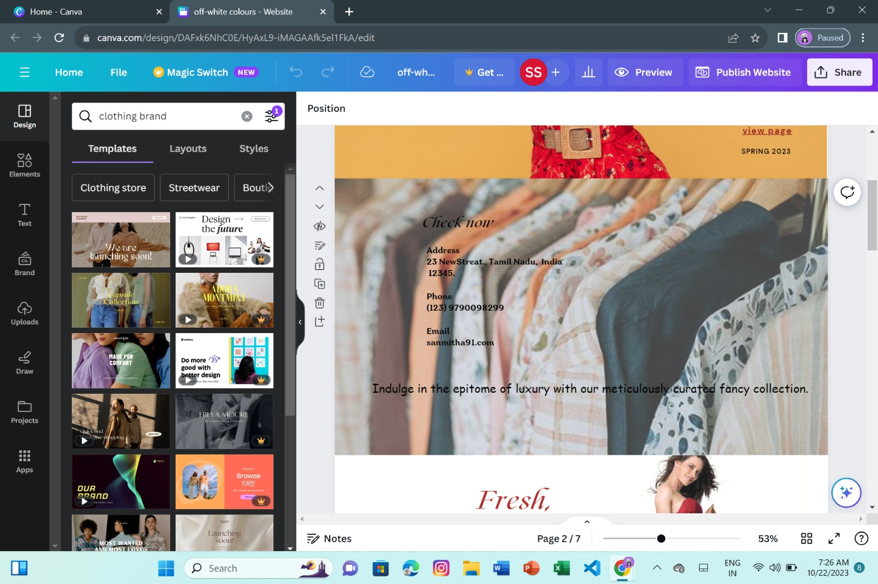

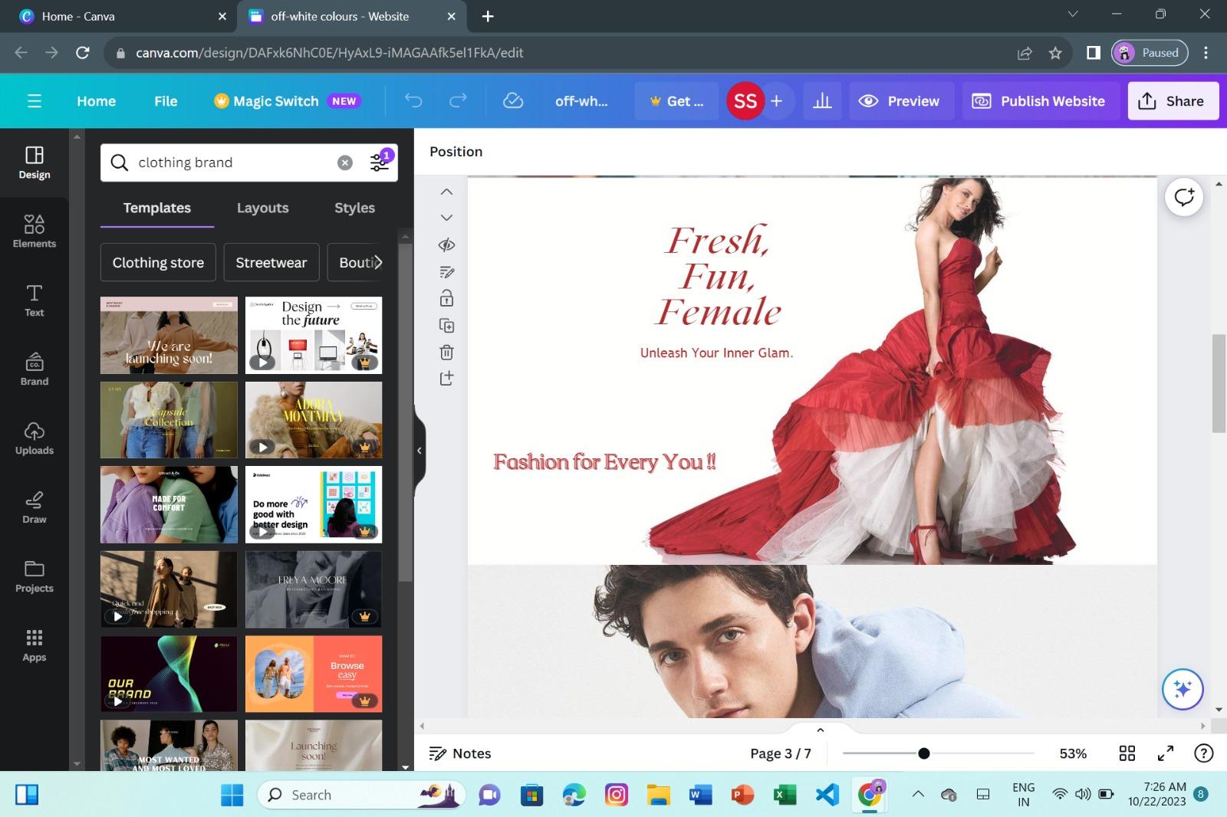

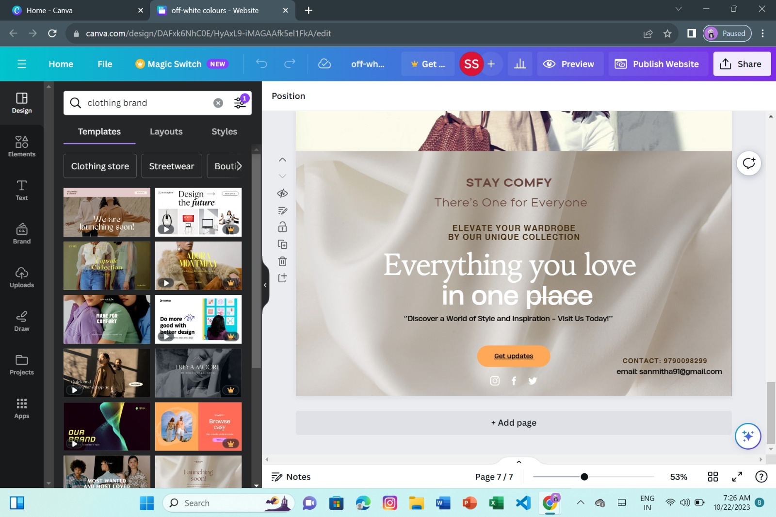

Dive into the canvas, and watch as your vision comes to life with every stroke of your digital brush. Let the magic of animation weave your brand's story into every pixel.

**Step 8: Previewing the website**

Click on the "Preview" button, typically located in the top right corner of the screen.

This action will generate a preview of your website design, allowing you to review its layout, content, and overall appearance as it would appear to your website visitors.

Take this opportunity to check for any visual or functional inconsistencies, ensuring that all elements are displaying properly and that the design is responsive across different devices and screen sizes.

Make any necessary adjustments or edits based on the preview, ensuring that the website is visually appealing, user-friendly, and effectively communicates your brand's message and offerings.

DESKTOP PREVIEW :

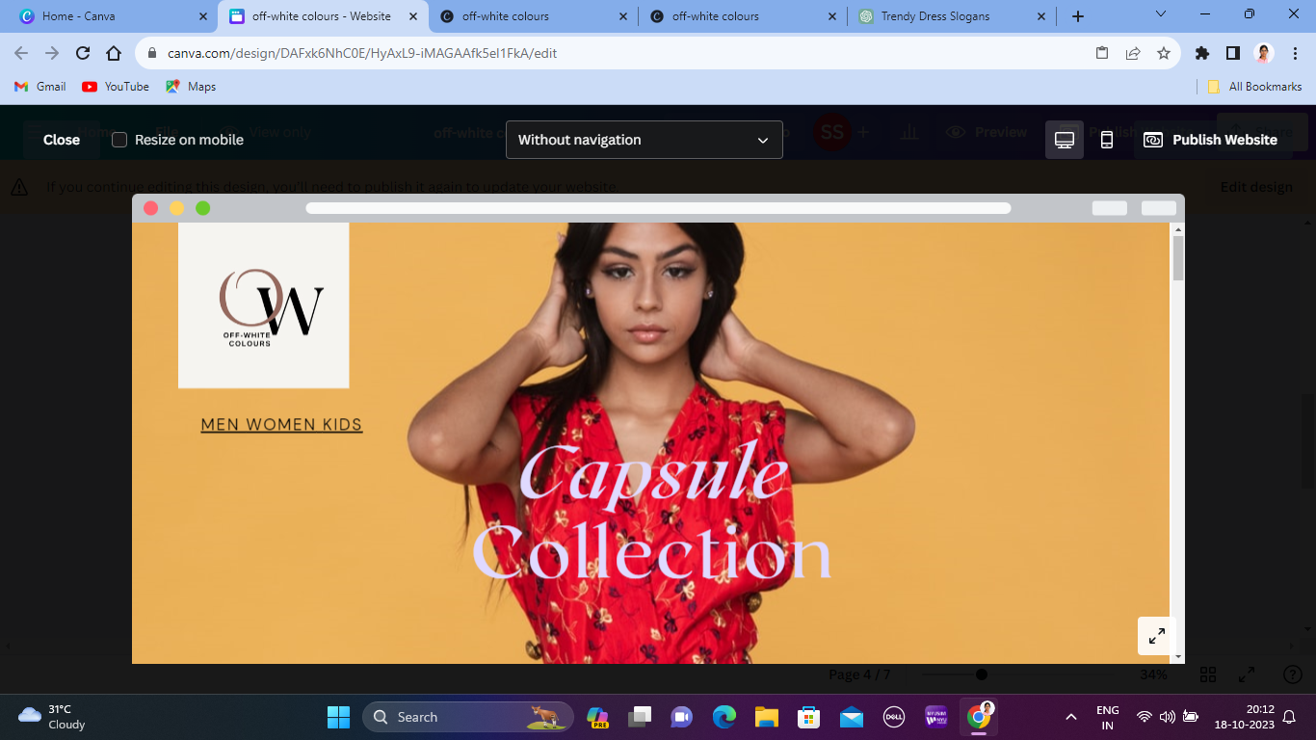

Before publishing the website we can use the preview option to cross check our customized design.

MOBILE PREVIEW 1:

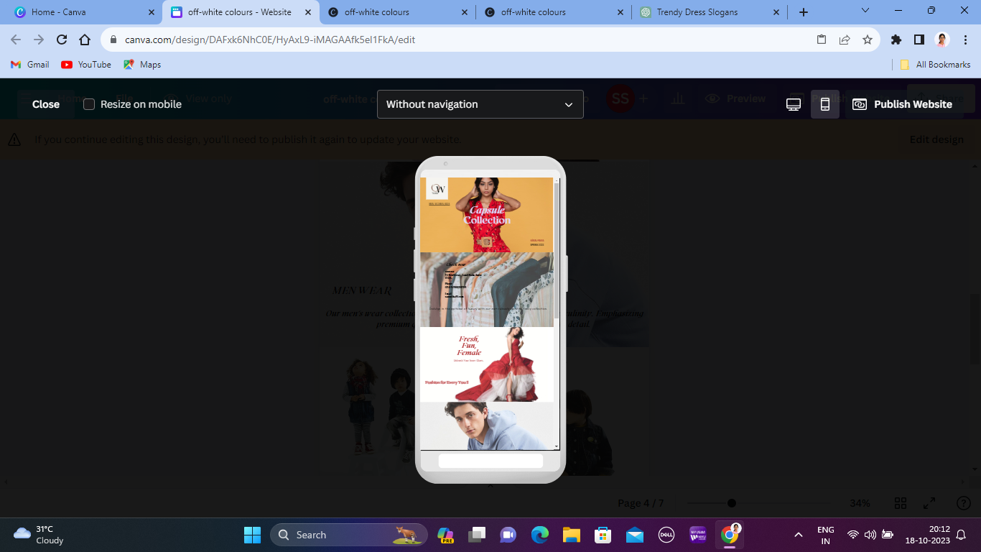

MOBILE PREVIEW 2:

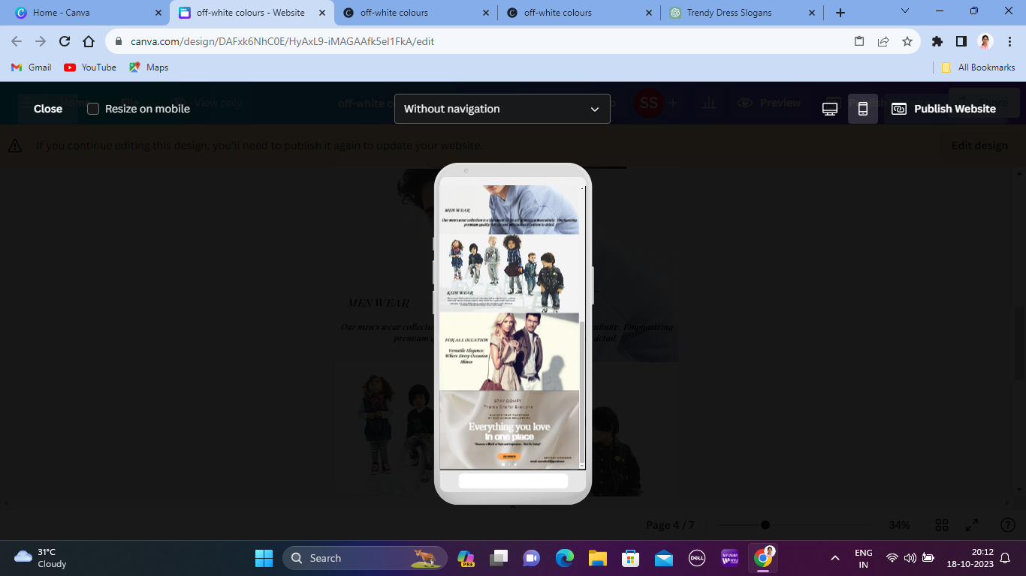

**6.3 Social media strategy**

**Visual Appeal and Brand Consistency:**

The website design created using Canva successfully embodies the brand's visual identity and values, showcasing a visually appealing layout with consistent branding elements, colors, and typography that resonate with the target audience and reflect the brand's unique aesthetic.

**User Engagement and Interaction:**

By integrating interactive design elements and user-friendly features, the website encourages enhanced user engagement, fostering meaningful interactions and seamless navigation for visitors. The intuitive user interface created through Canva's design tools facilitates a positive and engaging user experience, leading to increased time spent on the site and improved customer satisfaction.

**Increased Brand Awareness and Online Presence**:

The strategic use of Canva's design capabilities has contributed to the amplification of the brand's online presence, leading to increased brand visibility and recognition within the digital space. The visually captivating website design has successfully attracted a broader audience, generating heightened interest and awareness of the 'Off-White Colours' clothing brand.

**Conversion Rate Optimization (CRO):**

The website's conversion-focused design elements, created using Canva's intuitive features, have resulted in a notable improvement in the conversion rates, driving increased traffic and customer conversions. The seamless integration of compelling visuals, persuasive call-to-action buttons, and user-centric design principles has facilitated a streamlined conversion process, leading to a higher number of successful transactions and customer acquisitions.

**Social Media Impact and Engagement:**

Leveraging Canva's design tools for social media content creation has bolstered the brand's social media impact and engagement, resulting in a significant increase in follower growth, post engagement, and overall brand interaction across various social media platforms. The visually appealing and shareable content created using Canva's customizable templates has effectively resonated with the target audience, fostering a strong sense of community and brand loyalty among social media followers.



This is the final page on the website. Click on “**Get updates**” to view the social media platform of our online clothing store.

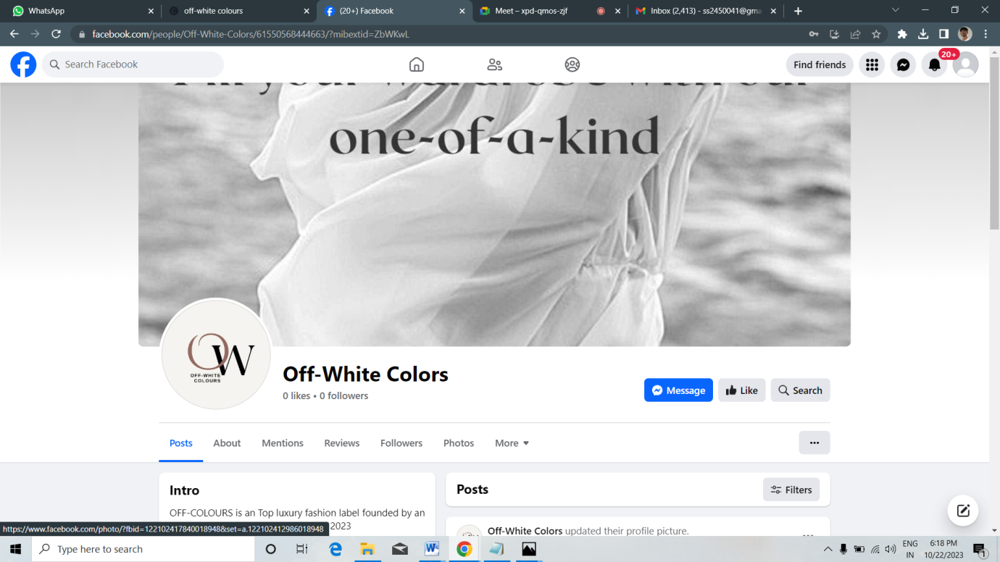After clicking the **“Get update”**option you’ll be navigate to our social media pages to get offers.

**6.4 Publishing the website**

**Step 1:**

Click on “**publish website**” option on the top right corner.

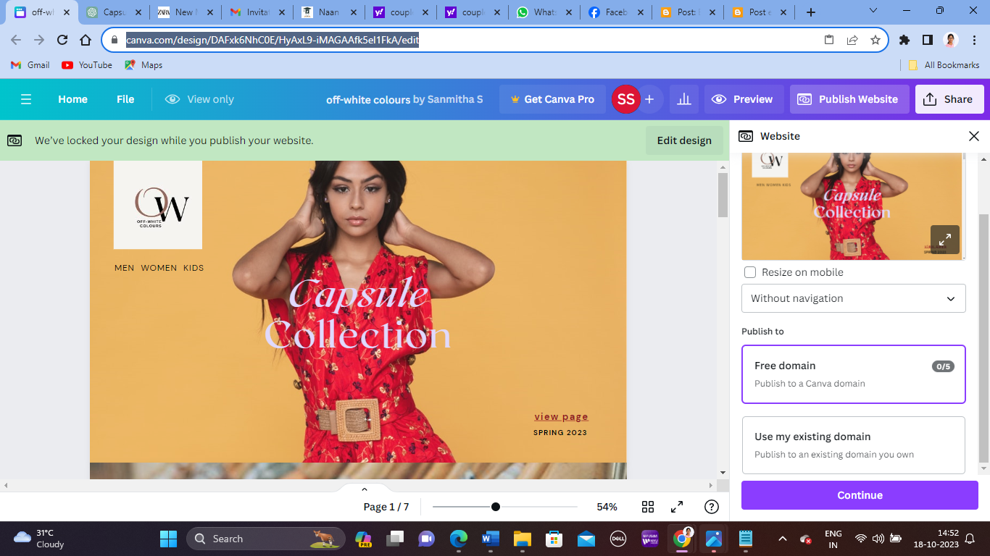

You will be navigated to this page and select the free domain to publish and click on continue.

**Step 2:** Give your website a quality look by claiming a subdomain.

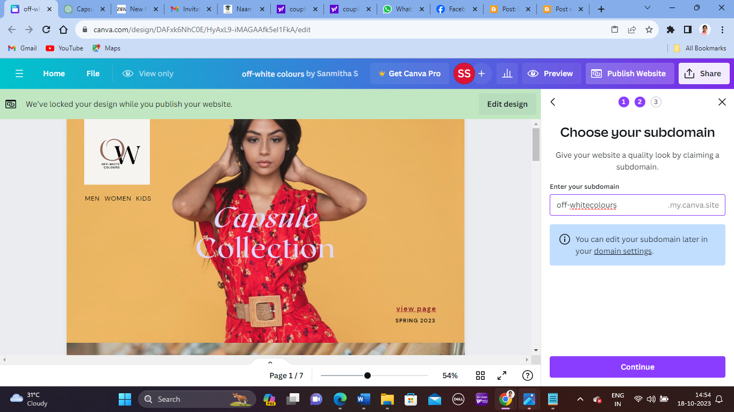

**Step 3:**

Customize the page URL and page description before publishing

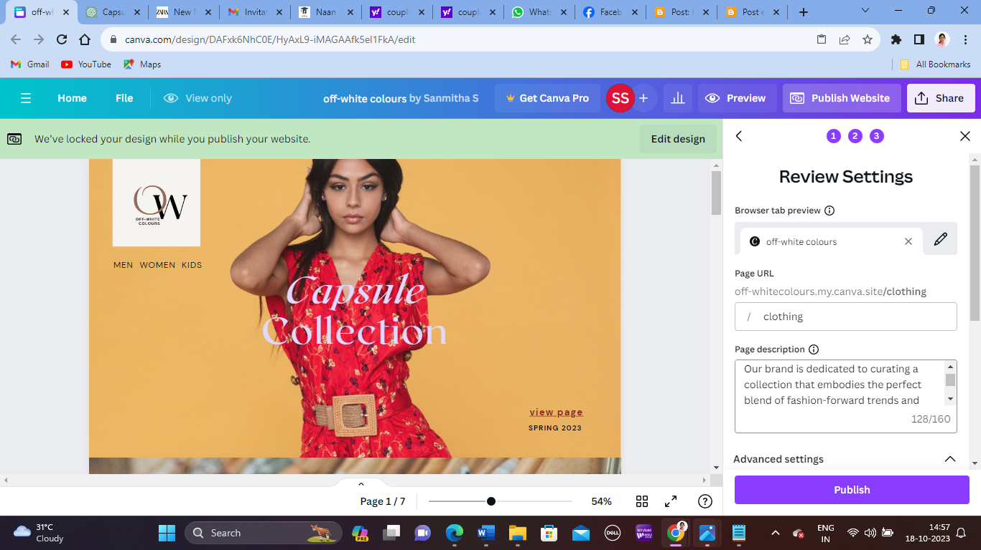

**Step 4:**

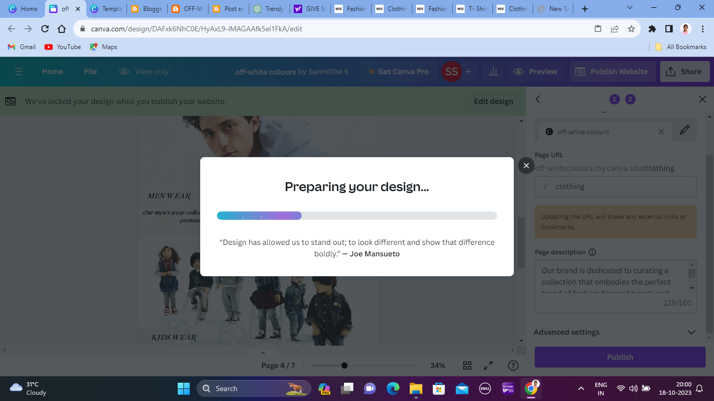

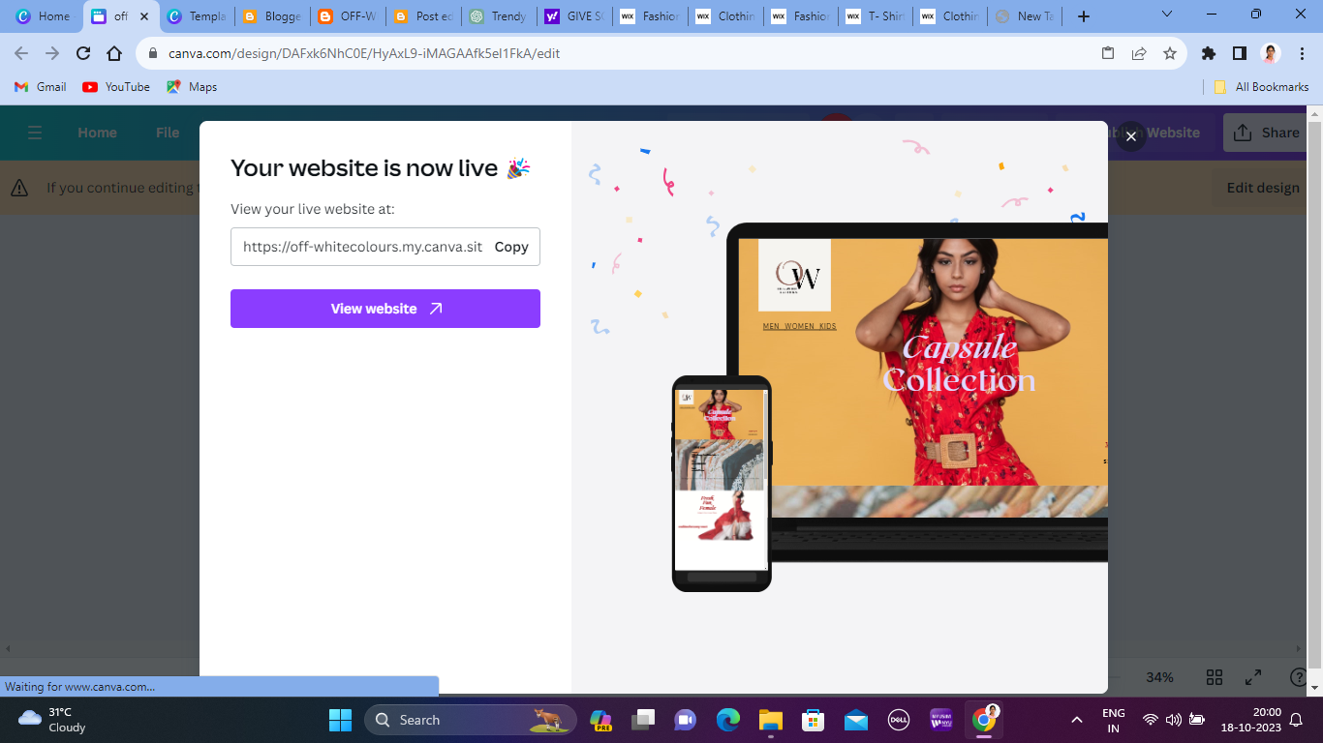

Your website has been successfully published and note down the website link

By using the link we can view our website.

**CHAPTER 7**

**RESULT AND ANALYSIS**

**7.1 Result:**

* Website Link:

<https://off-whitecolours.my.canva.site/clothing>

* Brand Name:

**OFF-WHITE COLOURS**

* Category:

Clothing Apparel

* Target Audience:

All- Men, Women, Kids

By clicking the above link you can find our website as shown in below figures.

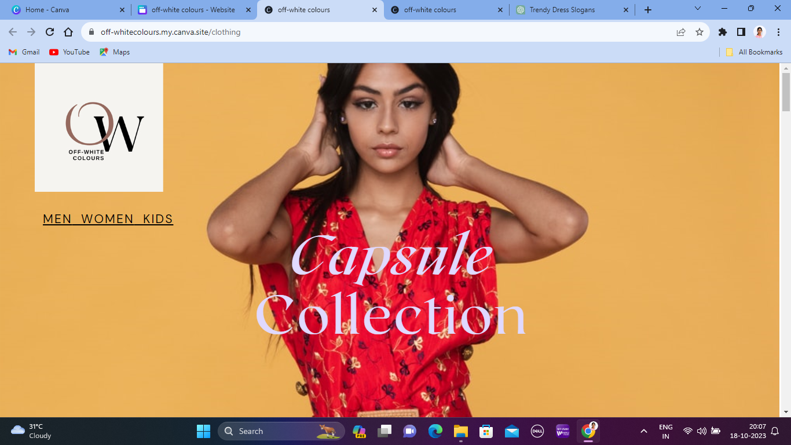

This is an impressive page at first which holds logo of our brand.

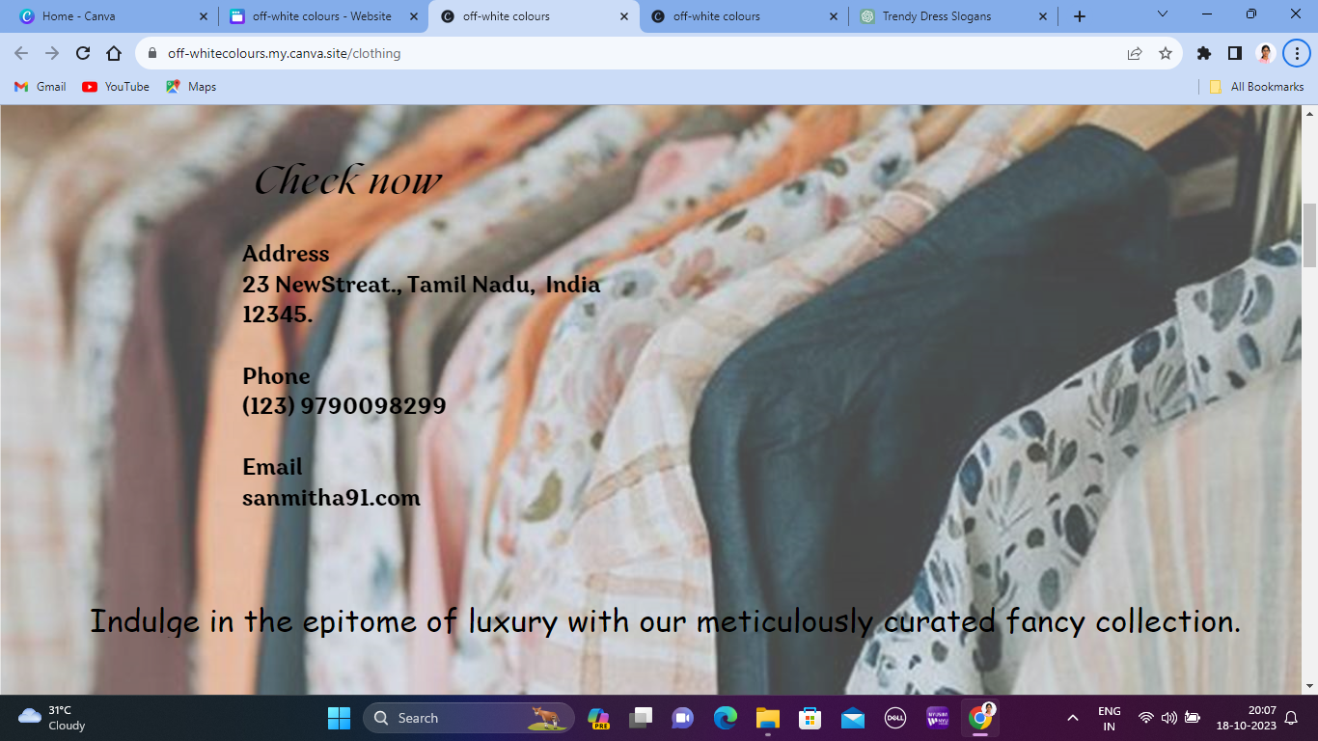

Our second page carries address to reach easily and also we have provided email with phone number for orders. Do check it out.

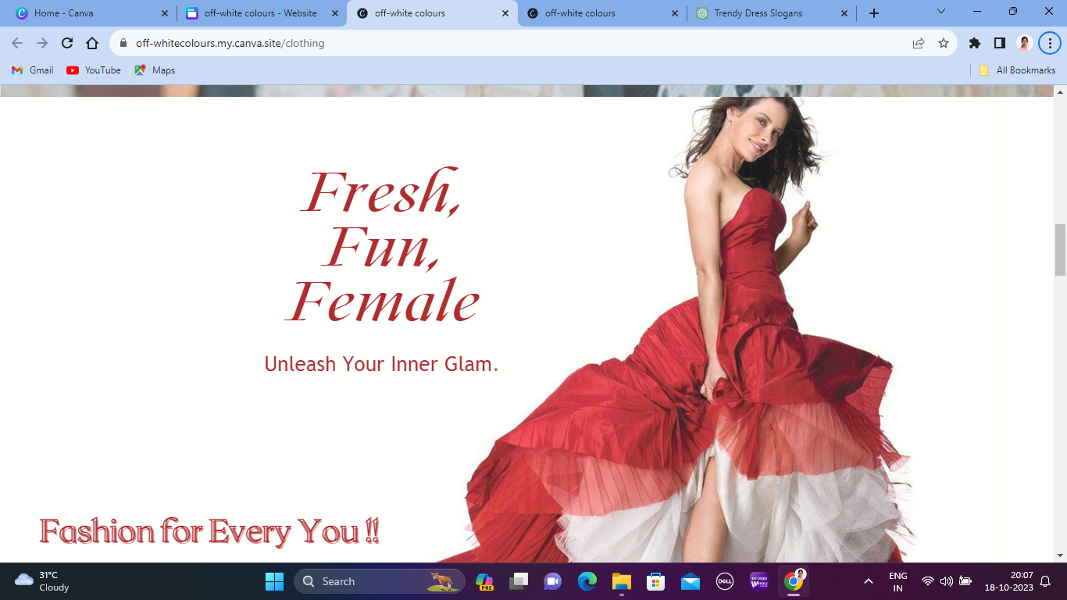

A Fashionable women’s collection with adorable styles and designs for all occations. A rich tapestry of option that reflects individual style.

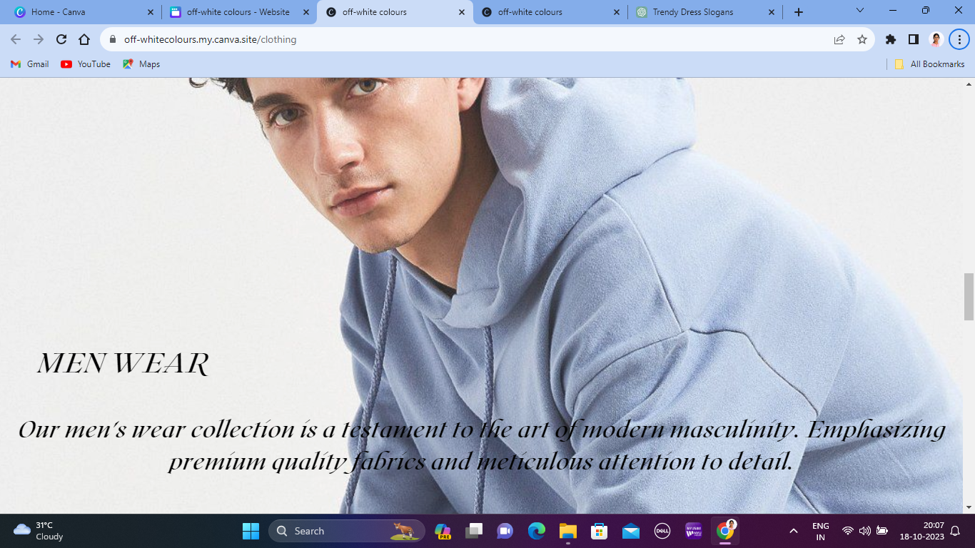

Classic and refined business suits, causal wear or sleek formal wear are the unique collections in men’s wear.

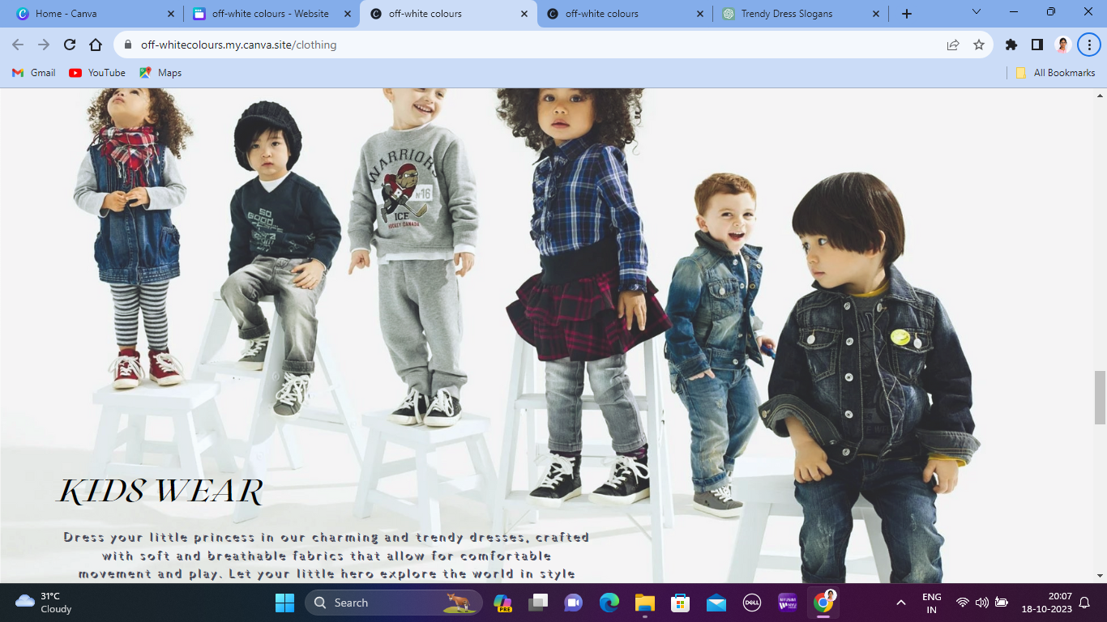

From playfull and comfortable everyday outfits to stylish and elagant formal wear, Kids wear collection to style your little world.

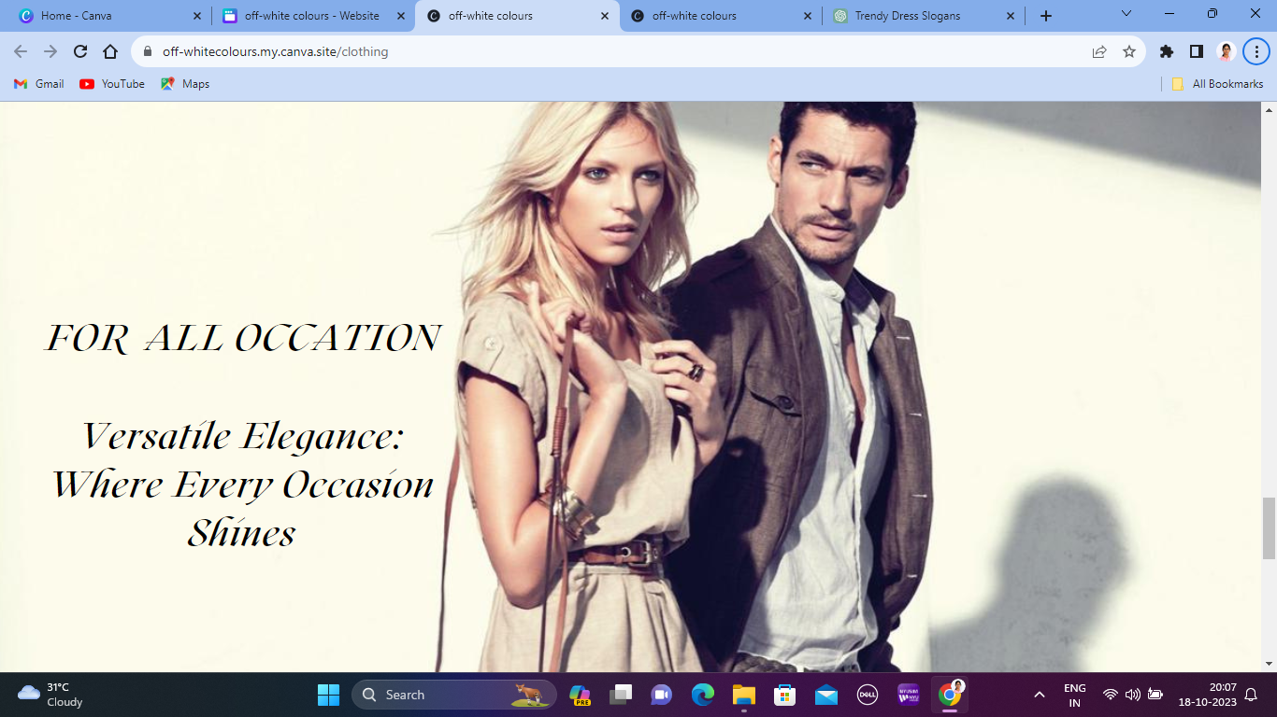

A cocktail party or a semiformal gatherings, the all occation dress serves fashion preference of the modern individual.

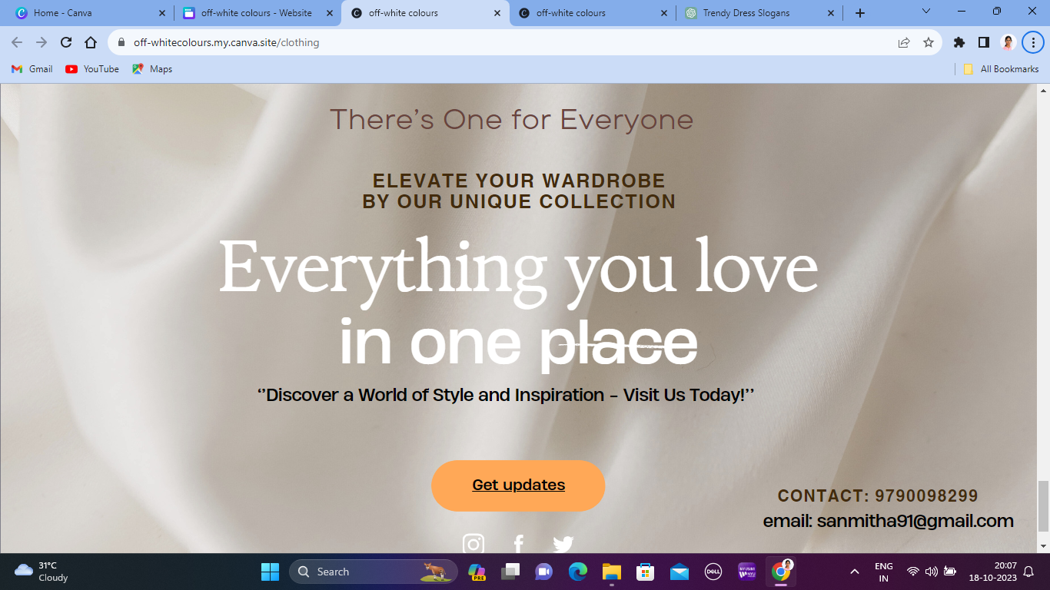

The final page of this website holds link into “**GET UPDATES**”. By clicking, it navigate to a social media business page.

**7.2 Analysis**

Content marketing plays a pivotal role in the success of any website, serving as a powerful tool for engaging and nurturing the target audience. In the context of 'Building a Website using Canva' for your brand, implementing a comprehensive content marketing strategy can significantly enhance brand visibility, credibility, and customer engagement.

**Compelling Visual Storytelling:**

Leveraging Canva's visual storytelling capabilities, create visually appealing and impactful content that communicates the brand's narrative, values, and unique selling points. Utilize captivating images, infographics, and videos to convey the brand's message and evoke an emotional response from the audience, fostering a strong and enduring connection with your brand.

**Engaging Blog Content:**

Develop an engaging and informative blog that offers valuable insights, industry trends, styling tips, and behind-the-scenes content related to your clothing brand. Use Canva to create visually appealing blog graphics, featured images, and infographics that accompany your blog posts, enhancing their appeal and shareability across various digital platforms.

**Social Media Campaigns:**

Craft visually striking social media posts using Canva's customizable templates to promote your brand's website launch, product releases, and special offers. Implement a consistent posting schedule across various social media platforms to maintain a strong online presence, and engage with your audience through interactive and visually appealing content, fostering meaningful interactions and building a loyal community around your brand.

**Email Newsletters and Promotions:**

Design visually appealing and informative email newsletters using Canva's customizable email templates to keep your subscribers updated on the latest product releases, exclusive offers, and brand news.

**CHAPTER 8**

**PROJECT SCOPE AND OBJECTIVES**

**1. Project Purpose and Justification:**

To develop a dedicated website showcasing the unique color palettes and designs of the Off-White clothing brand, allowing fans, designers, and fashion enthusiasts to explore and understand the brand's color story.

**2. Scope Description:**

The project will focus on cataloging and displaying the myriad of colors, patterns, and designs from various Off-White collections. The website will be user-friendly, mobile-responsive, and visually appealing, reflecting the aesthetic of the brand.

**3. Project Deliverables:**

A fully functional, interactive, and responsive website.A cataloged collection of Off-White's color palettes from various seasons/collections.Features like user account creation, favorites section, and color exploration tools.Analytics integration for tracking user engagement and behavior.An integrated blog or article section discussing the inspiration and stories behind certain color choices.

**4. Website Design and Development:**

Creating a visually appealing and user-friendly website using Canva's design tools and templates tailored to reflect the brand's unique identity and values.

**5. Content Creation and Customization:**

Generating engaging and informative content, including product descriptions, images, and multimedia elements, to effectively communicate the brand's story and offerings to the target audience.

**6. User Experience Optimization:**

Implementing intuitive navigation, interactive features, and responsive design elements to enhance user engagement and ensure a seamless browsing experience across various devices.

**7. Branding and Visual Identity:**

Establishing a cohesive and recognizable brand identity through consistent branding elements, color schemes, and typography that align with the brand's overall aesthetic and message.

**8. Social Media Integration and Marketing:**

Leveraging Canva's design capabilities to create captivating social media content that resonates with the target audience and enhances the brand's online visibility and engagement.

**CHAPTER 9**

**CONCLUSION**

**9.1 CONCLUSION:**

The "**Off-White Colors**" project provided a profound exploration into the distinct and iconic color palettes that define the Off-White brand. Through this initiative, we have uncovered the depth and design philosophy behind each hue, from subtle neutrals to vibrant statements, which together encapsulate the brand's unique aesthetic.

By diving into Off-White's color narratives, this project has further solidified our appreciation for the brand's innovative approach to fashion, where color becomes more than just a visual element; it's an emotion, a story, a statement. The collaborative efforts of our team have paved the way for deeper engagement with the brand, facilitating a richer understanding for both long-time enthusiasts and new admirers.

In conclusion, the "**Off-White Colors**" project stands as a testament to the intricate dance between fashion and color, emphasizing the power of hues in shaping brand identity and influencing fashion narratives globally. As we wrap up this initiative, we carry forward a renewed sense of inspiration, acknowledging the profound impact color holds within the fashion world.

**CHAPTER 10**

**APPENDIX**

**10.1 GETHUB LINK:**

[**https://github.com/SAN-1311/Digital_Marketing**](https://github.com/SAN-1311/Digital_Marketing)

**10.2 DEMO VIDEO LINK:**

[**https://youtu.be/xAiD24E_wJI?si=ntm7Rqm1D1r8i2K-**](https://youtu.be/xAiD24E_wJI?si=ntm7Rqm1D1r8i2K-)